**CREATED IMAGE**

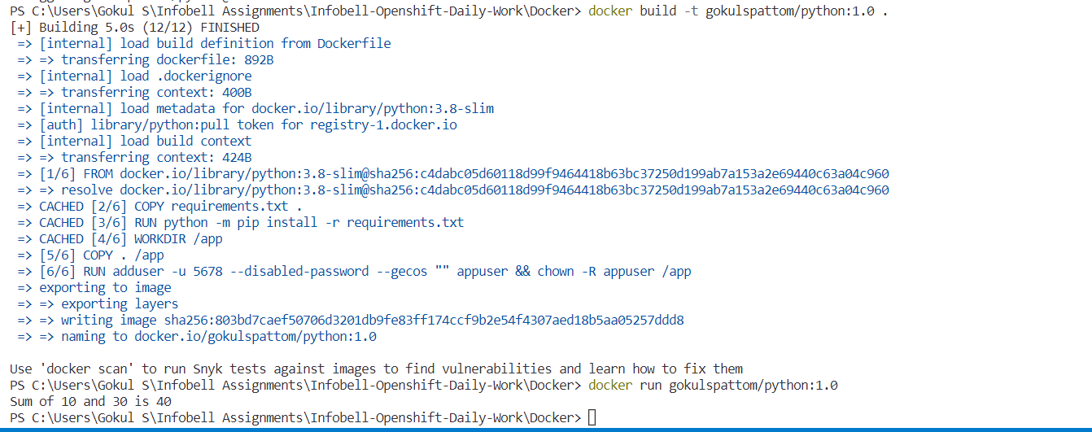

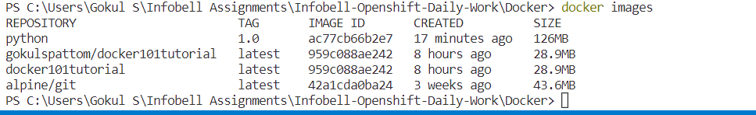

**DOCKER FILE FOR ADD.PY**

# For more information, please refer to https://aka.ms/vscode-docker-python

FROM python:3.8-slim

# Keeps Python from generating .pyc files in the container

ENV PYTHONDONTWRITEBYTECODE=1

# Turns off buffering for easier container logging

ENV PYTHONUNBUFFERED=1

# Install pip requirements

COPY requirements.txt .

RUN python -m pip install -r requirements.txt

WORKDIR /app

COPY . /app

# Creates a non-root user with an explicit UID and adds permission to access the /app folder

# For more info, please refer to https://aka.ms/vscode-docker-python-configure-containers

RUN adduser -u 5678 --disabled-password --gecos "" appuser && chown -R appuser /app

USER appuser

# During debugging, this entry point will be overridden. For more information, please refer to https://aka.ms/vscode-docker-python-debug

CMD ["python", "Add.py"]

**RUN THE CONTAINER**



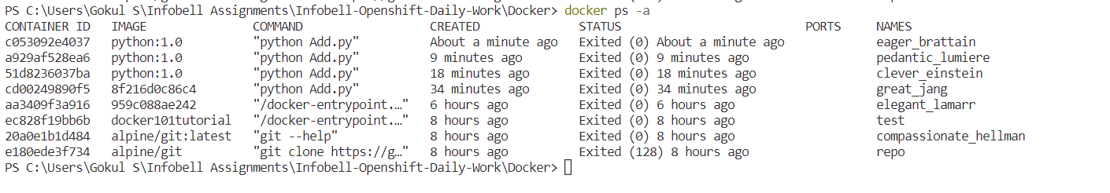

**PUSHING TO DOCHUB BY RENAMING IT**

